# Electronics and Instrumentation

## Objective

For this project to be successful a number of electronic systems are being designed. The goal of these systems is to provide a safe and reliable method to test, launch and recover all aspects of the rocket, while also collecting invaluable flight data, supporting payload and abiding by strict standards.

## Flight Critical Electronics

### Introduction

The purpose of the Flight Critical Electronics is to provide a data feed of the rocket’s location, speed, and acceleration to the ground base as well as control the firing of the recovery system. Last year the G-Wiz flight computer was used in conjunction with the BigRedBee GPS transmitter in order to cover these functions, however, the E&P Team decided not to use this flight computer again for SRT-3 due to its programming set up difficulty and unreliability due to system crashes. Therefore, we decided to select a new flight computer based on reliability, user-friendliness (programmability), pyrotechnic outputs, price, and the ability to accurately record altitude. The selection after looking at different brands came down to the AIM Xtra produced by Entacore Electronics or the TeleMega by Altus Metrum which both had more than the minimum two pyrotechnic channels required and also included various sensors and features to record the data necessary. The Aim Xtra was decided upon as the primary flight computer to be used in the rocket due to the higher degree of user programmability, reliable connection, and flexibility with battery setups and sensor inputs and outputs. Furthermore, the AIM Xtra includes the AIM Base and an attractive free flight data analysis GUI for the same price as the single microchip of the TeleMega.

### Primary Flight Computer and Vehicle Tracking

The primary flight computer is going to be the AIM Xtra by Entacore Electronics along with the AIM Base component which acts as a ground data packet receiver. Due to the operating frequency of 433 mHz the AIM Xtra along with the subsystems associated with the flight computer will be operated by a licensed Ham radio technician from the Electronics and Payload team. The AIM Xtra will operate by achieving a preflight satellite lock and await launch in order to begin data packet transmission which includes sensor values and GPS coordinates. Once launch has been achieved the AIM Xtra will maintain a data packet feed to the AIM Base connected to a laptop on the ground and will fire a drogue parachute charge at apogee then a main charge at a predetermined altitude. After descent and landing the AIM Xtra will continue to transmit data packets until recovered. If after landing data packets are dropped due to interference the recovery team will follow the last received data packet with GPS coordinates. The AIM Base relies on a link budget of around 145 dB and will output data to the AIM Xtra software in real-time data tracking.

### Secondary Flight Computer

The secondary flight computer will be the StratoLogger CF by PerfectFlite which will serve as a redundant safety system in the event the AIM Xtra fails to control recovery properly. The StratoLogger CF will function independently from the AIM Xtra and will provide data to compare for a more accurate flight analysis.

### Flight Computer and GPS Transmitter Application

In preliminary connectivity testing with last year’s BigRedBee GPS transmitter in the rocket carbon fiber assembly we discovered an RF blind-spot can occur when the BigRedBee faces the opposite direction of the receiving radio. This RF blind-spot causes dropped data packets and in order to prevent such a blind-spot and data gap the BigRedBee will be replaced with the AIM Xtra’s GPS transmitter functionality which is regarded as a more reliable system. The primary flight computer and altitude logger will be the AIM Xtra with the StratoLogger CF acting as its redundant system and altitude logger in order to record an accurate altitude as well as ensure correct deployment of the parachutes.

## Flight Sensors and Instruments

### Introduction

The E&P team is responsible for ensuring that the proper data is measured at all stages of flight. Not only this, but the data must also be transmitted, evaluated, and recorded as necessary. To this end, it is E&P’s job to make sure that the vehicle will receive the proper launch commands when it is time but not prematurely. After this, the vehicle needs to record some flight data for later analysis and analyze other flight data to determine if an engine shutoff is warranted.

### Data Transmission

There will be one data stream that will connect the vehicle to the team via a launch operations computer. The launch computer will be connected to an XBee/Yagi antenna system that will communicate with a second XBee/Yagi antenna system connected to an Arduino within the launch box. The launch box itself will handle all pre-flight operations as commanded by the launch operations computer. This will go up to and include opening the valve for oxidizer flow and igniting the engine. The launch box will accomplish its interactions with the vehicle through a hardwired connection between the vehicle and the launch box that will be disconnected when the vehicle lifts off from the rail. This two way communication between the launch operations computer and the rest of the launch system will be handled through MATLAB with commands being sent from the serial monitor of the program. All commands will be protected from outside interference through the use of a password phrase in front of every command. When the launch box does receive a verified command, it sends back an acknowledgment of the command. When the command is finished executing, a subsequent status update is sent confirming the command was completed.

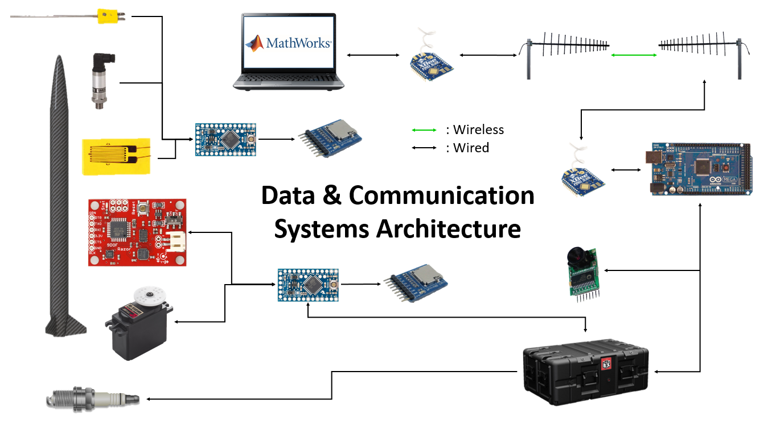

Figure . Data & Communication Systems Architecture Diagram

### Sensors

The propulsion team desires information on how the engine is performing from ignition to burn out. The information gathered from testing the scaled down prototype engine will help the propulsion team to redesign a better final engine, and data gathered from testing the final engine will help them to develop a thermodynamic model specific to our engine. As such, the rocket and launch pad this year will contain a variety of sensors to gather data deemed necessary or helpful during both flight and pre-flight operations. This will be useful for both testing and operational use of the rocket. For testing, temperature readings are a good indicator of the performance of the engine, so the temperature near the exit of the nozzle, on the outside of the combustion chamber, and in the plumbing will be measured. XC series Ceramic braided thermocouples are able to function at temperatures up to 2200o F and will be used to measure the temperatures on the nozzle and on the outside of the combustion chamber. The propulsion team also desires information on the mass flow rate of the oxidizer and the total mass flow rate. To address this, two Omega pressure transducers will be purchased to be used during engine tests. A 1,000 psi transducer will be used to measure combustion chamber pressure and a 2,000 psi transducer will be used to measure the pressure of the oxidizer in the plumbing. During flight, the rocket itself will contain an inertial measurement unit, two pressure sensors, and three thermocouples. The IMU will be a 9DOF Razor IMU[1] and includes a triple-axis accelerometer, triple-axis magnetometer, and a triple-axis gyroscope. It will be used to find an acceleration profile for the rocket as a whole. The pressure sensors will be PX171-2.0KSGIs[2]. One of the pressure sensors will be placed inside of the nitrous oxide tank and the other will be placed in the combustion chamber. The thermocouples will be high temperature K type placed on the outside of the combustion chamber, with the possibility of one thermocouple used in the oxidizer tank.

Two onboard microcontrollers (which will both be Arduino Pro Minis) will be used to read in the sensor data and store the data onto microSD cards for later analysis. One of the microcontrollers will handle the pressure transducers, thermocouples, and strain gauges, and the other sensor will collect and process the data from the IMU.

### Engine Safety Shutoff

The propulsion team has asked for the ability to perform an automatic emergency safety shutoff. Though there are still many unknowns where this is concerned, and thorough testing will be required of the sensors before any such system is implemented, a plan has been made for how this would be implemented. Once again, this system is contingent upon accurate and “non-jumpy” data from the sensors and will not be utilized if thorough testing does not prove to be completely successful.

If the IMU detects that the rocket has fallen below a certain orientation, the servo would be used to close the oxidizer tank and effectively turn off the engine. This would ensure that if the rocket were to lose stability, it would not begin to accelerate horizontally or downwards under propulsion from the engine. This orientation determination will be done with the use of the IMU’s gyroscope. Not only will a direct orientation check be continuously performed, but a rotational velocity check will be as well. If the vehicle ever begins to tilt off center too quickly, the engine shutoff will also be triggered. The temperature and pressure sensors would behave similarly with too high of a temperature or pressure triggering a safety shutdown as well. Though the effectiveness of these shutdowns is somewhat dependent on the speed of propulsion’s ball valve and servo motor combination, this extra layer of safety has no drawbacks other than a premature shutdown. This would still allow the recovery of the rocket and would simply mean a lower maximum altitude.

### Computation and Data Storage

As there is no need for the lots of computation on the vehicle, the BeagleBones from last year are being replaced with Arduino Pro Minis. This will greatly decrease the energy requirements of the vehicle while still allowing data collection, storage, and simple computations. The reason the Arduino Pro Minis were chosen is because they offer the same computational speed and power of the bulkier Arduino Mega. While the Minis do not possess all of the features of the Mega, in essence, they are a trim and sleek version of the Mega and will be able to accomplish everything we need them to be able to. In order to avoid the need to maintain a constant signal with the launch vehicle, all data being collected will be stored in onboard microSD cards. These will be connected to the Arduinos via a microSD card breakout board and will each have the capacity to store many tens of minutes of data in case any delays prevent a prompt launch while the vehicle is waiting on the launch pad.

With all of the sensors and communications that will be going on, it is of some concern that a single Arduino would have some difficulty accomplishing everything it needed to. As a result of this, we have opted to include a second Arduino to split the load. It is not expected that a third would be required because of the limited computations being done onboard the vehicle, but thorough testing will be done to ensure that two Arduinos will be more than enough for the requirements. That said, due to the fact that Arduino Pro Minis have been chosen, it would be quite simple to add additional Arduinos in to the system to split the computational load further or implement a verification system in regards to the engine shutoff.

### Power Needs

As there have been no “game-changing” developments in the world of batteries over the past year, much of the information is the same as in the SRT 2’s PDR. That is, that weight and heat resistance are the two primary concerns in choosing a battery. With this in mind (along with a very heavy energy density of 50.8 Watt-hours per pound), lithium-iron-phosphate was once again selected as the best of the battery types.

With this and the fact that the energy requirements are significantly less than last year’s (due to the elimination of the BeagleBones), the battery from last year will supply more than enough energy (at 60 Watt-hours) and will give us plenty of extra power should any team decide they need extra equipment. For example, propulsion will be using a servo to open their ball valve but have not decided on a specific servo yet. Not only this, but they have asked us to remain flexible in terms of power requirements while they continue to work towards a design of their system.

Table .. Flight Component Power Consumptions

|  |  |  |  |  |
| --- | --- | --- | --- | --- |
| **Sensor** | **Voltage** | **Current** | **Power** | **Quantity** |
| **draw** | **Draw (ea)** | **Draw (ea)** |
| **Thermocouple** | 3.3 V | Negligible | N/A | 3 |
| **IMU1** | 3.3 V | 1.2 mA | 3.96 mW | 1 |
| **Strain Gauge** | 5 V | 100 mA | 500 mW | 2 |
| **Pressure Transducer** | 12 V | 10 mA | 120 mW | 2 |
| **Arduino** | 5 V | 25 mA | 125 mW | 2 |
| **XBee** | 3 V | 95 mA | 285 mW | 2 |
| ***Flight Total:*** | *-* | *461.2 mA* | *2.064 W* | *12* |

## Avionics Mounting Bay

### Introduction

The primary two concerns for the rocket electronics bay are the reliable securement of electronics for the duration of the flight, and the ability to remove the electronics bay from the rocket body at will. The second requirement is due to the flight critical systems requiring manual checks before each flight to ensure that wiring and components are securely attached per competition rules. An additional benefit of this is allowing the easy modification to electronics should our mission parameters or goals change.

### Assembly

Our mounting bay, seen in Figure 1.1, will be overall fairly similar to the previous design from SRT 2, as it worked quite well, and is once again applicable to the current rocket design. We will construct the bay with the goals of portability, security of components and accessibility at the forefront. To meet these goals the design will consist of three horizontally placed circular bases connected by three bolts, with a several vertically and perpendicular placed platforms to actually mount our electronics.

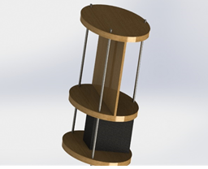

Figure .. Electronics Mounting Bay CAD Model

The three horizontal circular disks are stacked vertically and separated into two sections, the upper and lower. These platforms are ½ inch thick, and will be machined after construction to include holes for passing through wiring, and which will be dependent on the final layout of electronics included. The bases are also likely to include the smaller batteries mountings as they do not depend on axial direction like more of our sensitive electronics. The bases will be secured by running three low strength steel ¼ inch threaded rods through each base, which are held using hex locknuts above and below each (18 in total, 6 per rod).

The bottom sections primary purpose is to house the large battery that will power the rockets more needy components. The battery will likely be secured using three zip ties, two over the battery and through the lower base, and another perpendicular to the first two attached to an all through bolt. This process is simple, cheap and most importantly reliable, having proven satisfactory on the last flights. One major change to the design is in this lower section, and is the addition of two vertical (perpendicular to the base) boards on either side of the battery. These boards will provide additional mounting space if needed, as well as proving more security for the battery.

The top section will consist of a vertical (perpendicular to the base) platform similar to the two in the lower section, but will be placed in the middle of the bases, along their diameter. This plate will serve as the mounting wall for all of our needed electronics such as microcontrollers, GPS, IMU etc. Holes will be machined in the wall for wires similar to the bases.

The entire bay will be mounted to the rocket as it was last year, attaching to three vertical beams forming a “cage which the bay will attach to using brackets and screws that will likely include dampening materials to reduce vibrations.

## Electronic Launch Operations Control

### Introduction

In order to safely control the rocket before and through launch, an electronic control system was designed that will allow the operator to remotely send commands to and return live data from the rocket while it is on the ground. The IREC Advanced Category rule 7.2.2.1 requires all personnel to be 400 feet away, but the system must be capable of operating over a minimum safe distance of 1500 feet for testing, as specified in the Tripoli Rocketry Association Safe Launch Practices Distance Table. Arming and disarming the launch circuitry is required by IREC Advanced Category rule 3.4 and 7.2.2.2 such that the controller cannot provide any ignition signal to the rocket without first being armed. At minimum, the controls must allow filling and draining of the onboard nitrous tank, filling and draining of helium to pressurize the onboard tank, filling of an oxygen sting for starting, the actuation of either 2 quick disconnects (nitrous and helium) or one quick disconnect and a three-way selecting valve, signaling an onboard valve to open and start nitrous flow, and an igniter. To correctly fill the onboard nitrous tank with the correct amount of nitrous and helium, pressure, temperature, and load cell data will be streamed back live to the operator. A live, low frame-rate video feed is required to observe the vents and confirm the separation of quick disconnects, which will also be redundantly monitored by continuity across the connection. The launch control system must be in constant, reliable, and bandwidth-capable communication with the operator’s station. This year, more focus has been placed on creating a modular, expandable control system that will continue to meet the needs of future SRT teams and not require both AC and DC power to operate (as SRT-2’s did), all while reusing as much legacy SRT-2 hardware as possible.

### Launch Relay System

The Launch Relay System is the critical piece of launch hardware designed to meet these goals for SRT-3, and should offer more modularity and reliability than the previous launch controller. Initially, wired control was desired for the Launch Relay System to eliminate the wireless communication anomalies experienced last year, but the 1500 feet safety range required by Tripoli made this option prohibitively expensive. Category 6, BNC, serial, and USB connectors all work only under a range of about 300 feet. Category 6 cable alone is rated for lengths up to 328 feet, so an Ethernet extender must be used at both ends to give 1500 feet of range. Two appropriately sized extenders and 2000 feet of Category 6 cable would total $1970.98. A wireless system built using long-range xbee modules and external antennas can provide a much more streamlined solution with a 9 mile range for only ~$200 (discussed in detail in section 1.3.2). Future tests will be required to ensure the reliability of the wireless system, but a wired option is not an economically viable option.

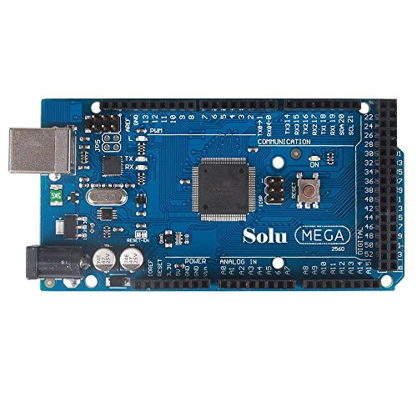

Figure .. Ximico Mega 2560 R3 Microcontroller

The Launch Relay System is based around the simple and reliable Arduino microcontroller boards. The Ximico Mega 2560 R3 (Figure 1.2) was chosen because it provides the IO capabilities (54 digital inputs/outputs, 16 analog inputs, 4 serial connections) as an Arduino Mega, but costs less and has more favorable reviews. This board leaves plenty of channels for future expansion, and provides a simple programming atmosphere that works well with xbee.

The two helium AC solenoids from the SRT-2 control system will be replaced with two Extreme-Pressure Stainless Steel Solenoid Valves (McMaster-1190N23), which operate at 24 VDC and withstand up to 3000 psi, which is safe for the inert helium gas at 2000-2500 psi. Though this solution is not ideal, it is the best option because it allows everything from last year except 2 relays and 2 solenoids to be reused, including 2 car batteries. This was more economical than converting the remainder of the system to AC, and will not significantly complicate the Launch Relay System.

The relay control circuit diagram in the Launch Relay System is shown in Figure 1.4. The Ximico controller is powered by a separate 9V battery, so that failure of either car battery will not disable the controller. Dual N-Channel FQP30N06 MOSFETs rated at 60 V, 20 A (Figure 1.3) switch the ground of the relays to activate individual channels, and incorporate standard 10K Ω pull-down and 100 Ω safety resistors to protect the controller and transistor. System arming is achieved by a separately controlled relay that switches the (+) side of every other relay to either +12V (armed), or ground (disarmed). Two 28VDC relays with 12 volt coils provide the higher switching ability for the new helium solenoids. Only 5 of the 9 12V auto relays must be purchased because they are the legacy SRT-2 model, and all relays feature a 1000V flyback diode to prevent damage to themselves and the switching transistors. To provide 24V for the two helium relays, a second car battery is connected in series, and this system could easily power more 24V devices, if needed. A Duralast Ignition Coil will be used to control the planned spark ignition system, which operates at 12V and discharges ~50,000V when it’s transistor switches on for a few milliseconds and then switches off.

Table .. Launch Box Upgrade Cost for Control Channels



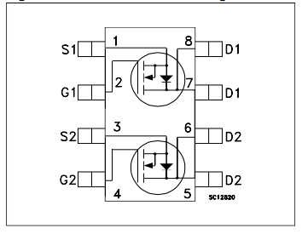

Figure .. Dual N-Ch. MOSFET FQP30N06

Table 1.2 shows an itemized breakdown of the components needed to upgrade the control channels on the Launch Relay System. Pressure transducers, thermocouples, and an ArduCam OV2640 unit must also connect to the sensor inputs on the Ximico to provide an accurate mass measurement during filling and confirm that the rocket is ready for launch. These systems will require knowing propulsions exact monitoring needs, so they will continue to be refined throughout the year. A proof of concept to test the ability of a 5V Arduino UNO channel to switch a 12V auto relay through a MOSFET was developed and tested successfully. The relay clicked back and forth for several seconds and gave audible confirmation that the circuit worked.

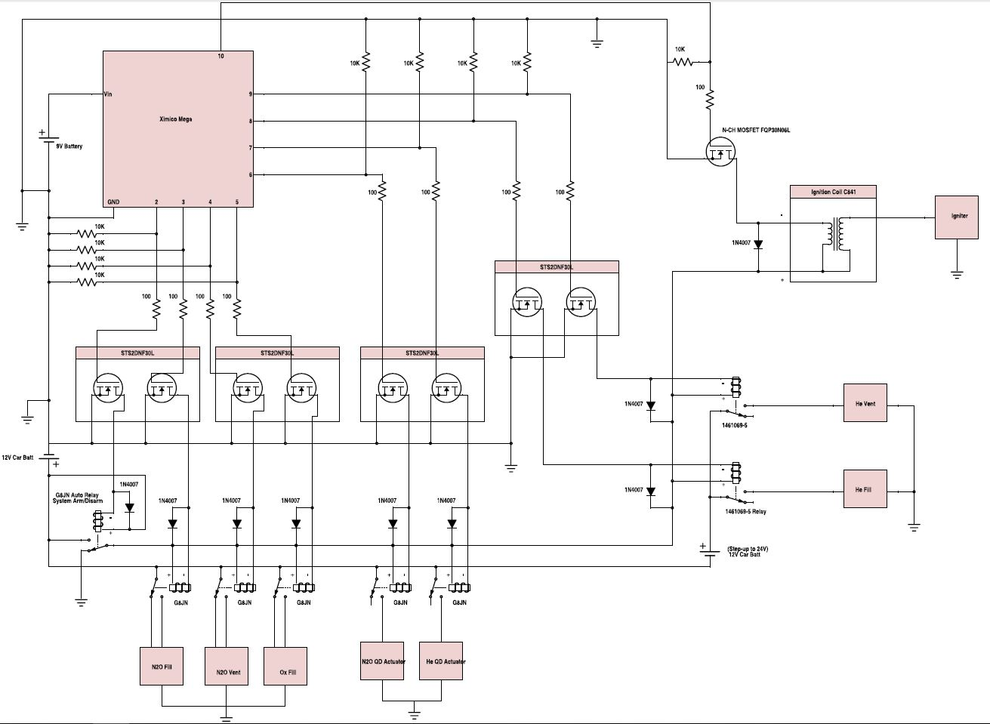

Figure .. Launch Relay System Circuit Diagram

### Ignition Control

New propulsion requirements dictated a need for a new electric starting system. Two options are currently being developed: ignition system control from the Launch Relay System, and ignition system control through an onboard flight computer. Providing ignition control from the Launch Relay System would require a 5V signal wire (and a ground) from the Ximico to directly signal the onboard nitrous valve to open, and then fall off as the rocket launches. The 50,000 V igniter pulse must also be connected to the rocket and fall away, but the distance between metallic paths in the rocket may simplify the connection by relying on the resistance of the air. The second ignition option would give the benefit of facilitating a future restartable engine and eliminate the need for external break away wires, but would require careful research to make sure ITAR regulations are not violated. Two other design challenges are fitting the relatively heavy ignition coil (1.6 lbs.) onboard, and electrically isolating the radio distortion produced by the sparking process from the sensitive flight electronics. The integration of an electrical ignition system will be continually evaluated with the Propulsion Team over the next few months.

## Wiring

All wiring and connections of electronics, with an emphasis on those which are critical to flight function, will adhere to all rules outlined by ESRA. All wire will be copper stranded, insulated and a minimum of 22 AWG, unless a component requires the use of a smaller size wire. All wire connections will be terminated in a screw-type or crimp-type terminal block, or soldered to components which have built-in solder terminals. All individual wires will be fastened together, through the use of zip-ties, to make a wiring harness. The harness will be secured to the electronics mounting bay. Any splices, joints or exposed wires will be insulated with clear heat shrink tubing. All dry cell batteries shall be secured to the avionics structure using approved battery holders, all gel cell batteries will be clamped to the structure connected with the use of JST or “Quick-Disconnect” terminal connectors.

# Payload

## Objective

The purpose of the payload is to attain a scientific or technical achievement which is unique to this competition. Furthermore, per rules outlined for this competition, the payload is to weigh a minimum of ten pounds and remain independent of the rocket dynamics. The Team this year had once again been offered a unique opportunity to not only fulfill the requirements of above, but also help another university, while simultaneously providing actual engineering knowledge to the community.

## Design Considerations

Our payload this year is planned to be a CubeSat designed and built by a separate team of students in the aerospace engineering department at the University of Sydney, led by Dr. Xiaofeng Wu. We will collaborate with this team to test some properties or components of the satellite which has yet to be determined. This team will ship the CubeSat to us, and some of the key student designers are expected to join us at the ESRA competition this summer.

To achieve the objective outlined for the payload, several aspects were considered in the conceptual design. In addition to adhering to the rules set in place by the competition, the payload is expected to be of quality constructability--given our budget and time considerations, and to provide scientific merit which is relevant to the Texas A&M Rocketry Team specifically, all while remaining within the size constraints determined by the structure. One area that we wanted to pay particular attention to was making our payload as unique as possible, as this both makes our project stand out and raises awareness, but also is more likely to garner our team additional points at the competition.

Many tests are of merit to a satellite entering orbit, however as our rocket does not reach that altitude, some limits are inherently placed on us. With this in mind, we have chosen to focus on forces that the satellite will experience during a full scale launch which our rocket is capable of simulating. Many testable properties should present themselves, chief among them vibrations, which we attempted to measure last year, and we will attempt to measure again. We are planning on doing this with piezoelectric sensor purchased last year, and the Arduino platform. We are also planning on measuring other parameters that the Australian team wishes to know, which will be coordinated and designed as the teams move forward.